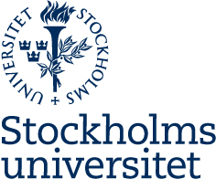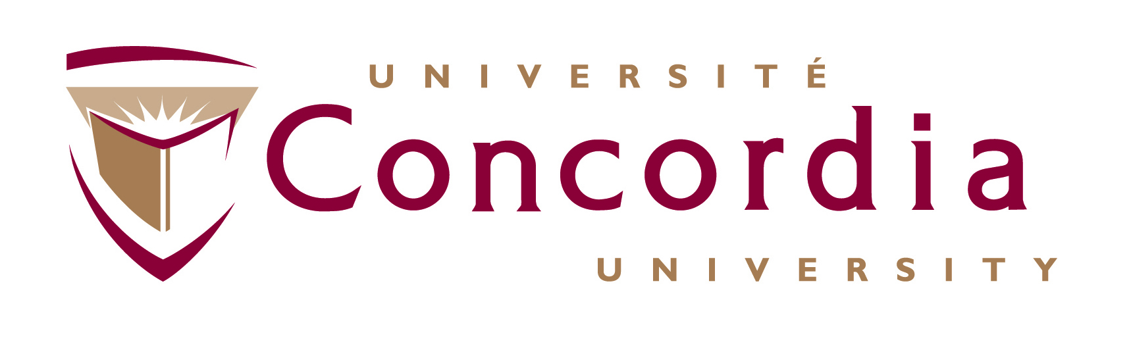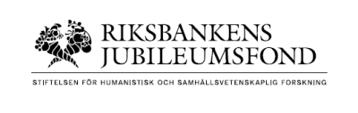

Panel debate: How interest groups contribute to problem-solving on the world stage

Live stream: https://www.ekohist.su.se/om-oss/evenemang/interest-groups-international-organizations-and-global-problem-solving-capacity-1.389048
11 June 2018 13:30-15:00
In partnership with the Department of Economic History and International Relations, and Department of Political Science at Stockholm University, Department of Political Science at Concordia University in Montreal, and the Stockholm Centre for Civil Society Studies at the Stockholm School of Economics. The workshop is generously funded by The Swedish Foundation for Humanities and Social Sciences (Riksbankens Jubileumsfond) (Dnr F17-1189:1).
When are international non-governmental organizations (INGOs) ‘magic bullets’ in global governance? Why do non-state actors become involved in international affairs? When global governance began to build after the cold war, INGOs, including business organizations, civil society organizations, foundations, and professional associations, were widely welcomed in new intergovernmental organizations. Social scientists suggested that non-governmental and transnational actors could have positive regulatory impacts in society alongside governments, forming networks and partnerships. Even today there is a widespread belief that cooperation among organizations across the public-private sector divide has positive effects on the innovation and problem-solving capacity of multilateral organizations.
Yet, in the 1990s and early 2000s, negative voices began to challenge the early proponents for the positive roles of INGOs in global governance. There has been increasing debate about the motivations of INGOs to become involved globally, and growing concerns about their lack of representation and diversity. Should global governance institutions develop clear policies on the inclusion of INGOs, including provisions for their participation, regulation, and representativeness? Could formal efforts to increase INGO participation in global governance have negative unintended consequences? Are INGOs more effective or influential in national rather than global political arenas, or is there variation by sector and issue area?

Panelists:
Cliff Bob, Professor, Duquesne University
André Boustany, Research Scientist at Duke University and Monterey Bay Aquarium
Nina Hall, Assistant Professor, Johns Hopkins SAIS Bologna
Karl Hallding, Stockholm Environment Institute
Lisa McIntosh Sundstrom, Professor, University of British Columbia
Axel Wenblad, Chairman of the Board, WWF, Sweden
Moderator:
Elizabeth Bloodgood: Associate Professor of Political Science, Concordia University

